**PROJECT DESIGN PHASE-II**

**DATA FLOW DIAGRAMS**

**Team ID: PNT2022TMID52303**

**Project Name: Smart Waste Management for Metropolitian Cities**

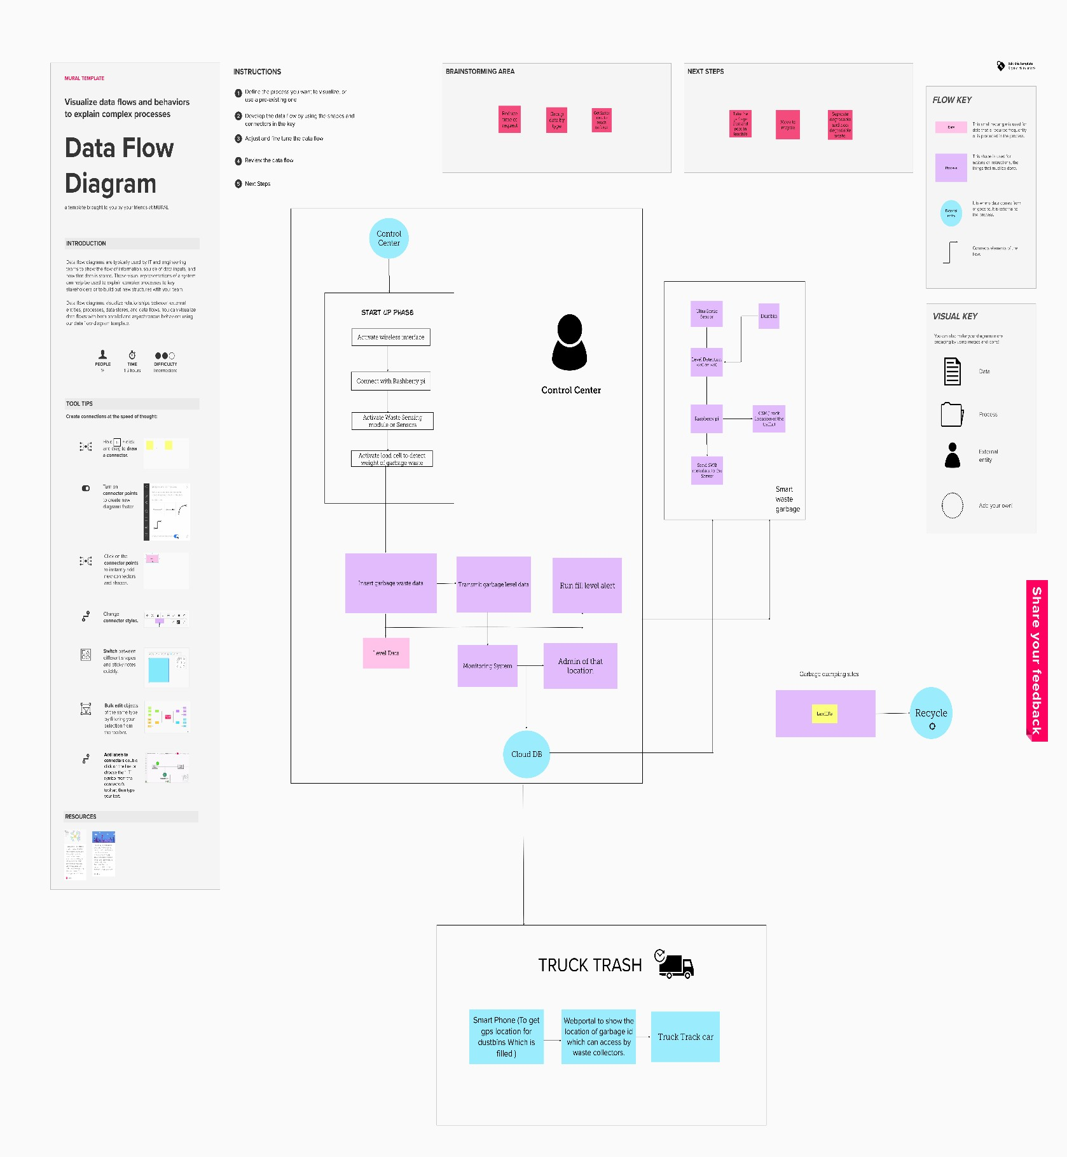

# Data Flow Diagrams:

A Data Flow Diagram (DFD) is a traditional visual representation of the information flows within a system. A neat and clear DFD can depict the right amount of the system requirement graphically. It shows how data enters and leaves the system, what changes the information, and where data is stored.

A smart waste management platform uses analytics to translate the data gather in your bins into actionable insights to help you improve your waste services.

You can receive data on metric such as:

1. The first test conducted is the situation where the garbage bin is empty or its garbage level is very low
2. Then, the bin is filled with more garbage until its level has surpassed the first threshold value, which is set to 80% then the first warning SMS is being sent, as depicted
3. The first notification SMS sent by the system, once the waste reaches the level of 85% full. The second notification SMS sent by the system, indicating that bin is at least 95% full and the garbage needs to be collected immediately.
4. Locations prone to overflow.
5. The number of bins needed to avoid overflowing waste. The number of collection services that could be saved.
6. The amount of fuel that could be saved. 7.The driving distance that could be save